

# Coursework Report

**Interaction Design (COMP1649)**

**Student Name: Nguyen Hai Dang**

**Class: GT0868**

**Instructor: Mr. Nguyen Minh Long**

**Coordinator: Mr. Eur Ing Dr Mary Kiernan**

**I. Introduction**

The aim of this report is to build a high fidelity prototype applet will be for a mobile phone or tablet that provides a welcome to your institution for new students. This should cover the essential information they need to know which may be found on either on the University of Greenwich website or on your institution’s. Reviewing the information found in the literature review will help to design the prototype. Having the understanding of what is required to make a applet usable and accessible for all new students. As can be seen in this report, it has detailed information of how to design and develop a successful website following rules, guidelines and requirements that are needed to create this prototype.

1. **Literature Review**
2. **Similar System**

Mobile App is a software designed for mobile devices such as a phone or tablet, a task made ​​especially for the needs of the user, such as games, calendar, music player, Google maps map... Mobile app brings a large and general concept for all applications running on mobile devices (including native app and web app).

Native App is an application designed to run on a specific operating system of a device and only for those device which often must be adjusted to run on different devices. The native app run faster mobile app about performance. Native app can run in offline mode because it uses data which was cached that user accessed online in the last time. The native app has ability to access to hardware (such as cameras, GPS, recording equipment ...) and have access to the local authorities, such as copy, create, write, read files (in memory of the mobile), and contact information, personal information, making calls, texting and email... But a native app can only run on a specific operating system. Updating multiple versions for native app is an obstacle because these devices running older OS version will not be installed. A native app for mobile numbers as: Yahoo Messenger app, Facebook app, Google Maps app…

For web app, or applications that run in a web browser, as part or all of the software that is downloaded from a web of applications for each run. With Mobile web app, then the app will run on a browser which mobile devices. A web app for mobile numbers as: <http://m.facebook.com>, [http://m.stanford.edu](http://m.stanford.edu/...%20)... Mobile web app don`t need to install and can run on all mobile browser supports HTML and java script versions. The updated version will come immediately and transparent to the user after they run it. Besides, weaknesses of the mobile web app is not running as fast as native app, always must work in online mode.

Now, we can combine the both native app and web app through web view component. With this, we can take advantage of the strengths of the two model and overcome weaknesses. All code developed for applications just only with HTML 5, CSS and JavaScript.

1. **Accessibility and Usability**

When new student click on web page of a mobile applet, they would have some idea on first impressions. They maybe like or hate it. Each student have principles to estimate an applet susscessfull or failure.

When student access the applet, they would feel interested in if information was present clearly and readable combine use a image, icon, video and sound reasonably but if abuse more a image, icon, video and sound unreasonable would making student feel discomfortable. Should not use an advertisement and popup windows, it’s very complicated.

The home page a very simple looking layout can indeed be very successful. However on what type of information the designer chooses to input on the home page can be disastrous if not correctly done or not professionally looking.

1. **Requirements Specification**
2. **Scenario**

The aim of this project is to develop an interface for a new students, providing information about the University of Greenwich, about a programme, help students find accomodation, fees, student life at university.

1. **Objectives**

* To determine the appropriate medium to deliver this interface.
* To determine the target user for this interface.
* To develop a suitable design using the knowledge attained in section 3.
* To test the design against an end user before implementation of code.
* To develop a prototype interface to effectively communicate this design to the end user.

1. **Assumptions**

* Web Mobile Applet run on smart phone or tablet.
* User difficulty finding information on the website of the University of Greenwich.
* User want to find their information of course, programs and support services.
* User is an international student need to find University of Greenwich explorer.
* Use it for registration or communication with other student as a forum or social networking.
* Create opportunities for students to work with business.

1. **Contraints**

Student must have smartphone or tablet running on mobile OS. The current students have to log into system to view timetables, mark of courses, information about course and exam. An introduction page about University of Greenwich as education programs, other departments and information contact to the new students. Difficulties in finding recruiters for graduate students.

1. **Required Functions**

* Student must be able to find information and student life at university.
* Student must be able to search for a specific information.
* Student must be able to find information of bussiness services.
* Student must be able to get online support.

1. **Target Users**

There will be two kinds of user for this portotype. The most frequent client base

will be new student. This user may find information about their life at university, course, fees, bussiness services and get online support. The second user is parents of new students. They may check the course of new student, check fees and finance, they can read the rule for parent.

1. **Analysis**
2. **Cognition**
   1. **Attention**

The applet was build to support for the new students to easily find new learning environment, show the necessary information on smart phone or tablet so this applet was create with user-friendly interface to facilitate students in finding information, the information must be updated quickly and accurately, and to the it is clear that the important information so that students can easily identify.

* 1. **Memory**

On the website University of Greenwich have many information and complicated, it make new student confuse when thay want find their information need. This applet was design and build on smart phone and tablet with reasonable layout. It present necessary information for student, this applet have 5-7 line for each page so student can easy remember information.

* 1. **Perception**

On this applet have use combined with image, video to noctice what information the student read. Choose the simple font of text, readable and smooth color. Students would feel interested in and easily to use this applet.

1. **Use Case Diagram**



1. **Task Analysis**
2. **Introduction**

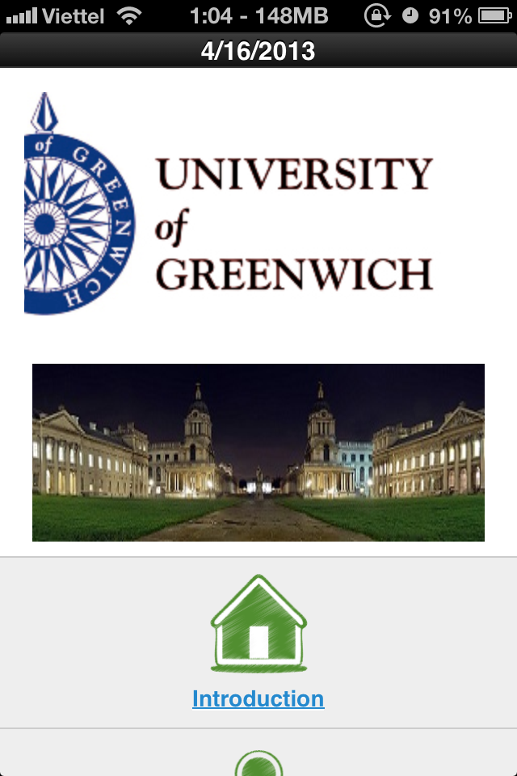

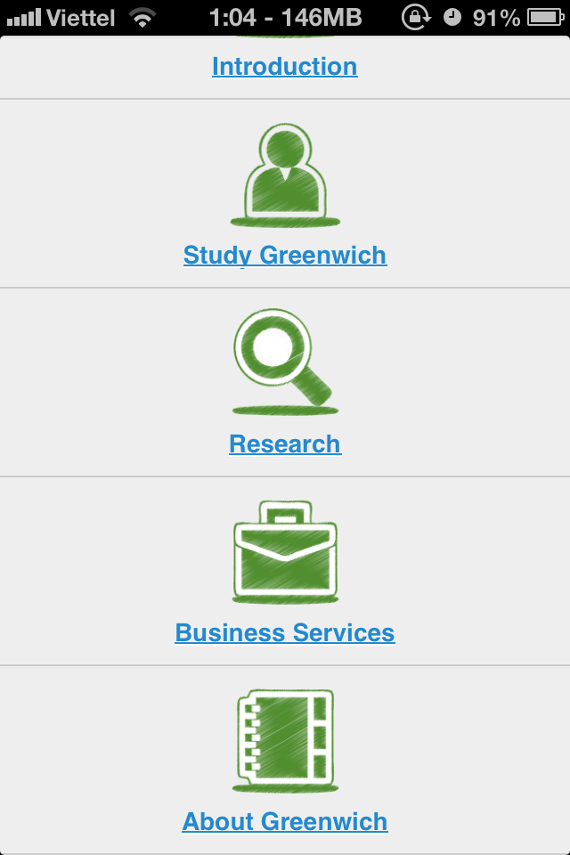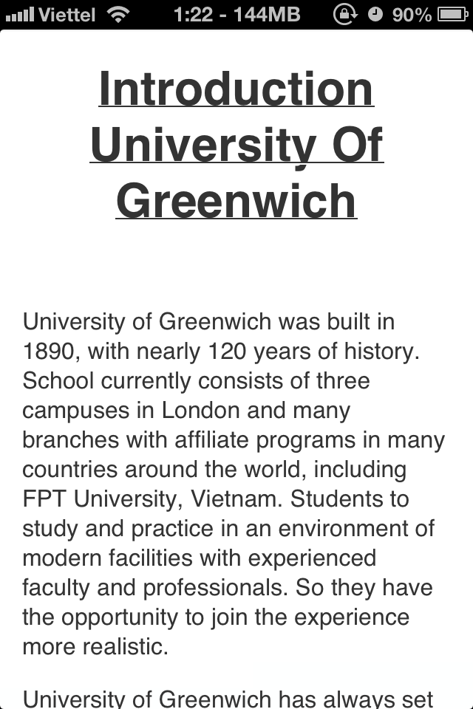

1. **Study at Greenwich**

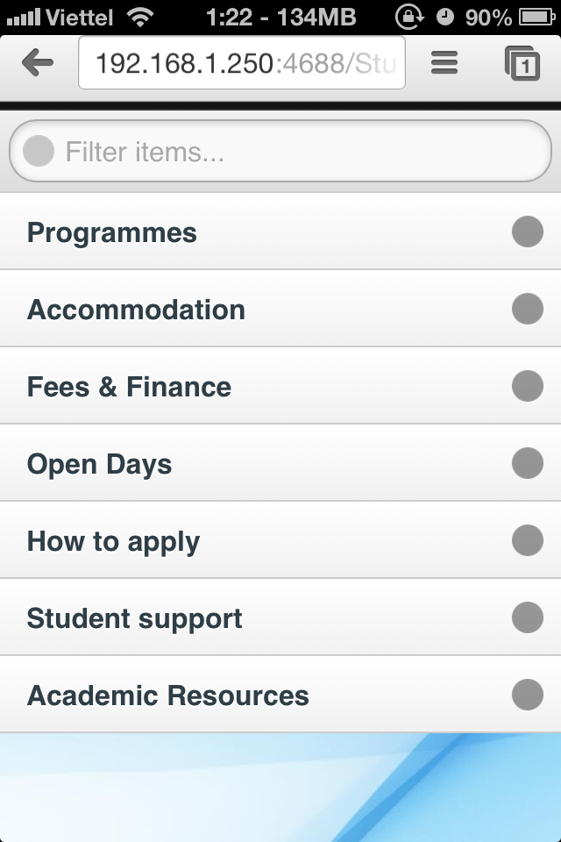

**1.1. Programmes:** include programs as Undergraduate programmes, combined honours programmes, Postgraduate programmes, and Research programmes.

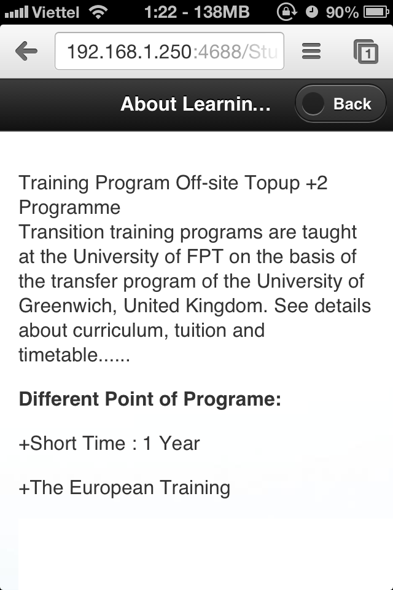

**1.2. Accommodation:** provide students with high-quality accommodation situated on or near main campuses.

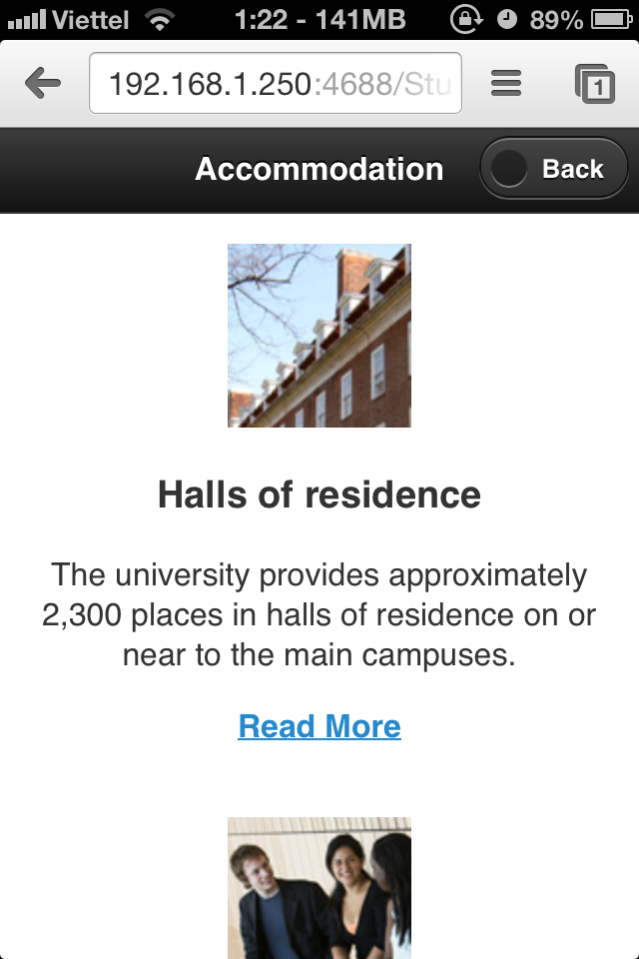

**1.3. Student Fees and Finance:** student can check the undergraduate fees, bursaries and scholarships

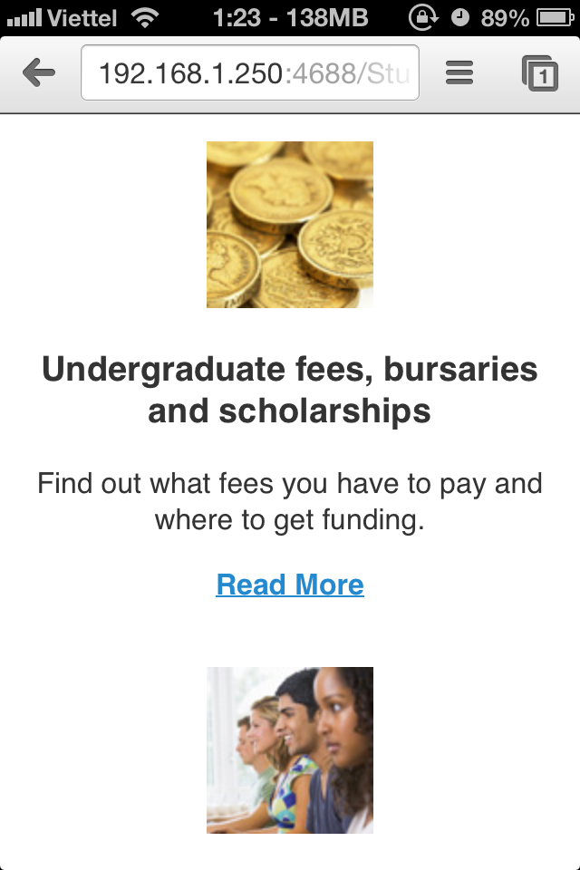

**1.4. Open Days:** find out what the University of Greenwich has to offer and get a feel for what it would be like to study here by attending one of our open days.

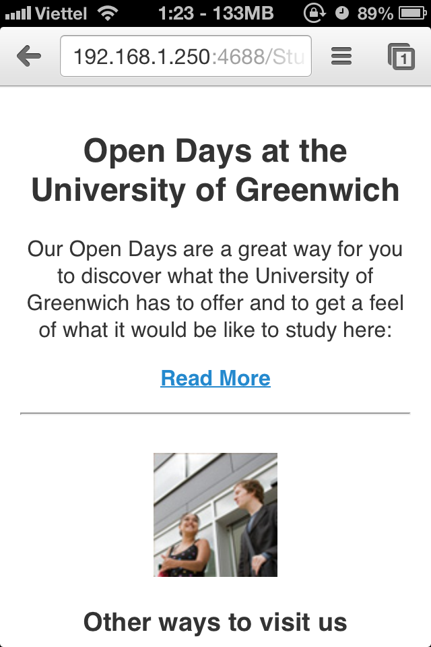

**1.5. How to Apply:** find out how you can make an application and what will happen next when student have found a programmes that they interests.

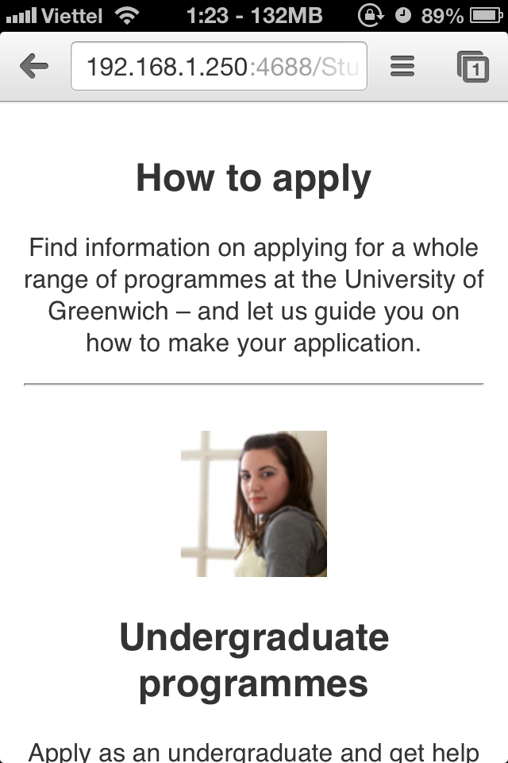

**1.6. Student Support:** offer students extensive support and welfare services that help with all aspects of university life, and beyond.

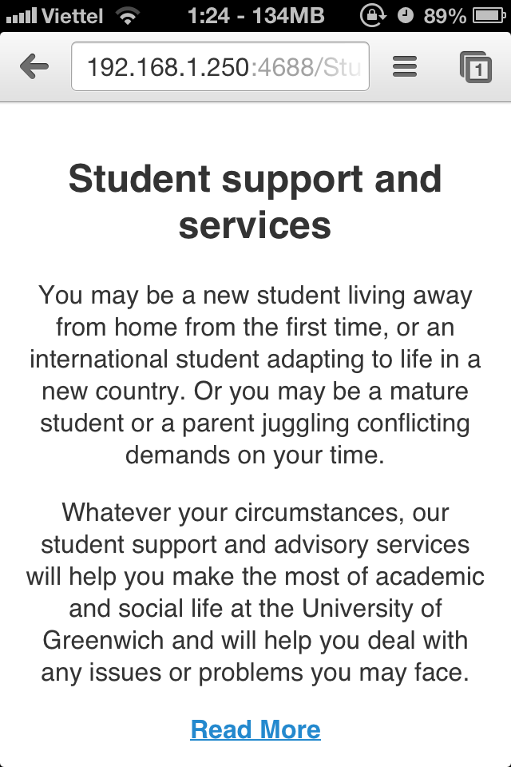

**1.7. Academic Resources:** Student can find information about course content, Undergraduate Program and schedule.

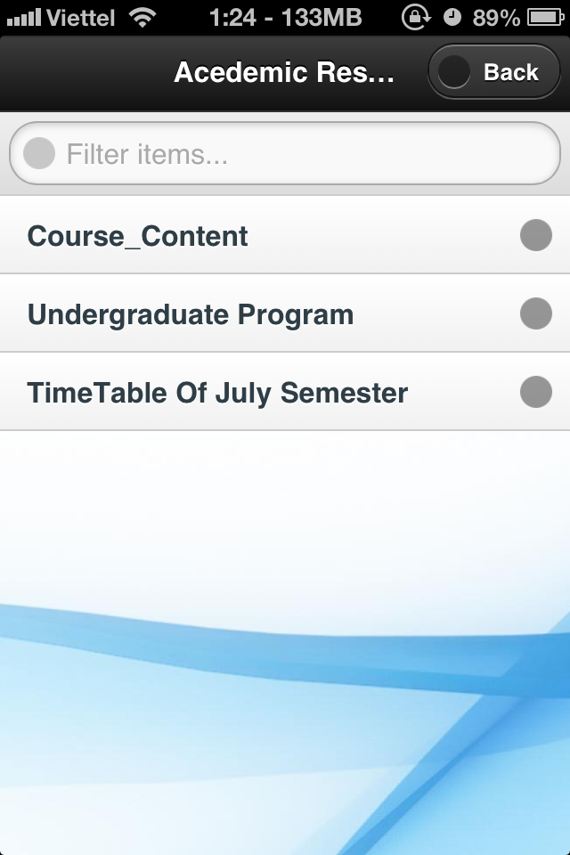

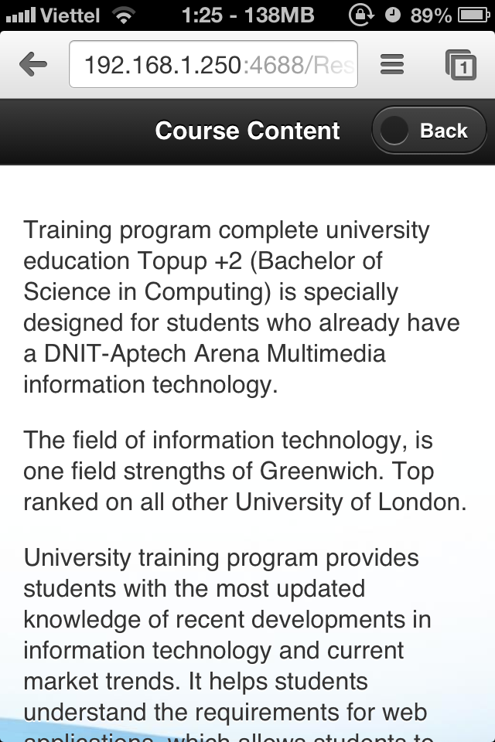

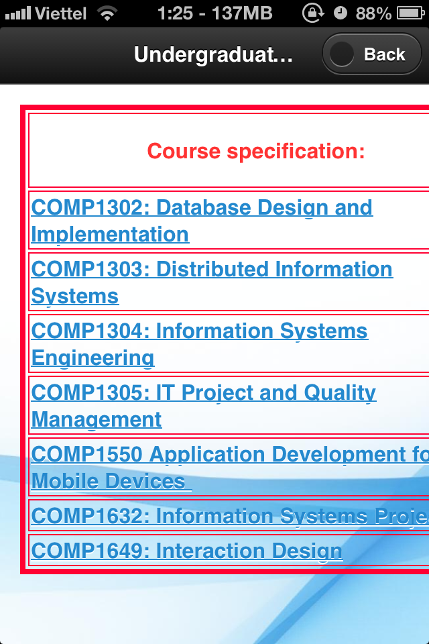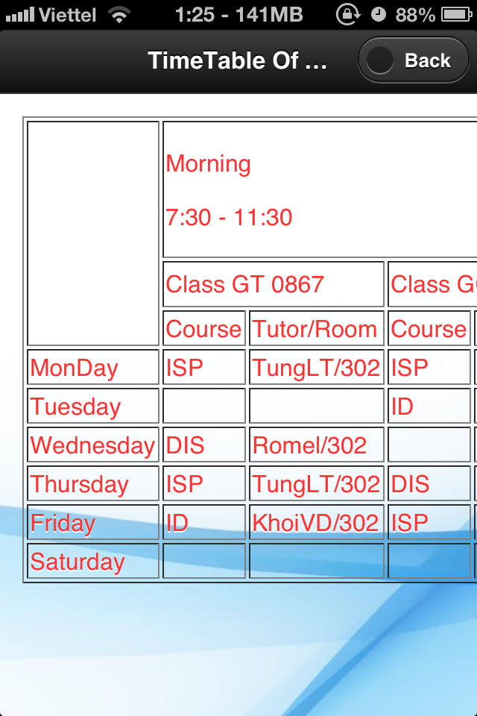

**2. Research:** User can search any information that they want and system will filter all result with key search. Results of the search may be programs of student, services to support for student or information contact of services that students are caring.

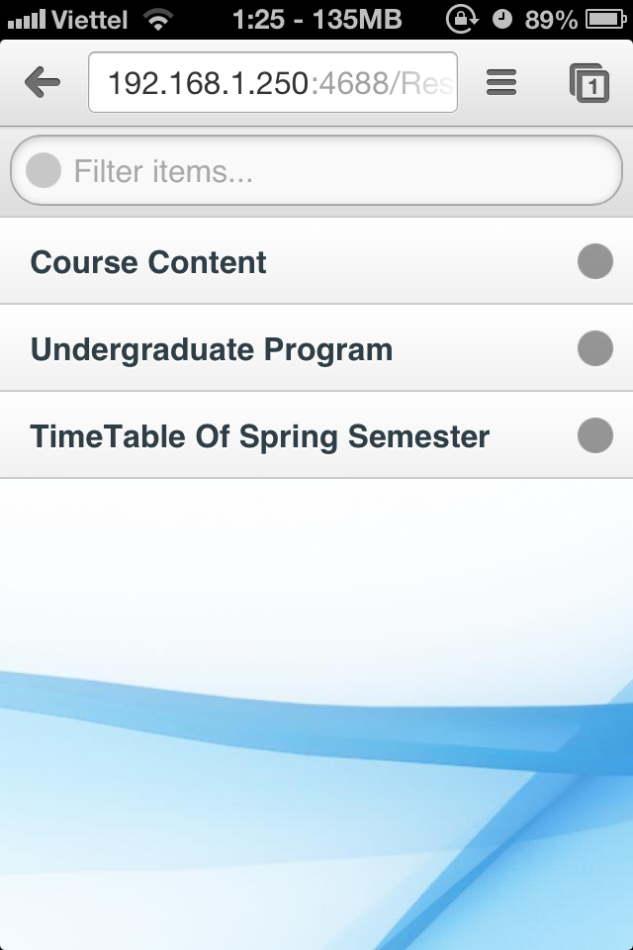

1. **Bussiness Services**

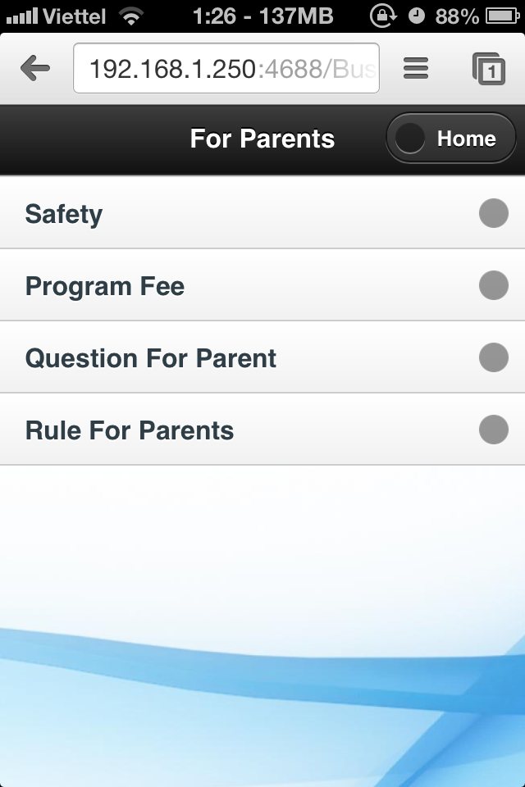

**3.1. Safety:** Student and their parents can check the information about the security at University of Greenwich.

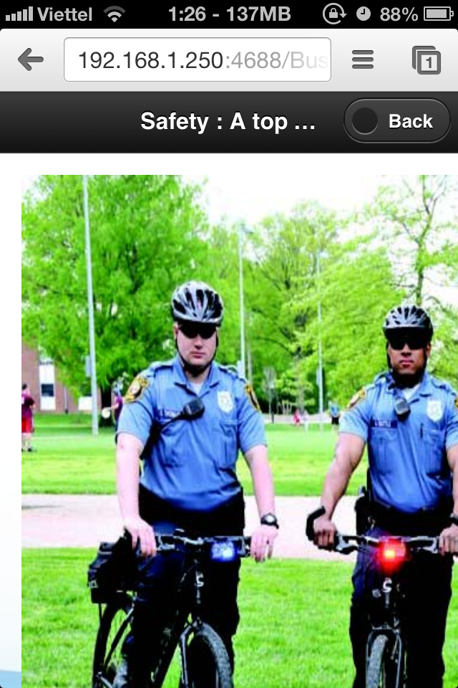

**3.2. Programme Fee for Parent:** parent of student can check the fee of programme they must pay for.

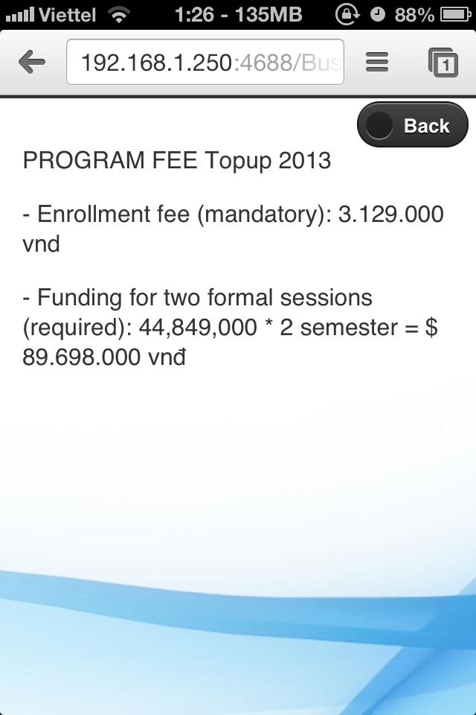

**3.3. Questtion for Parent**

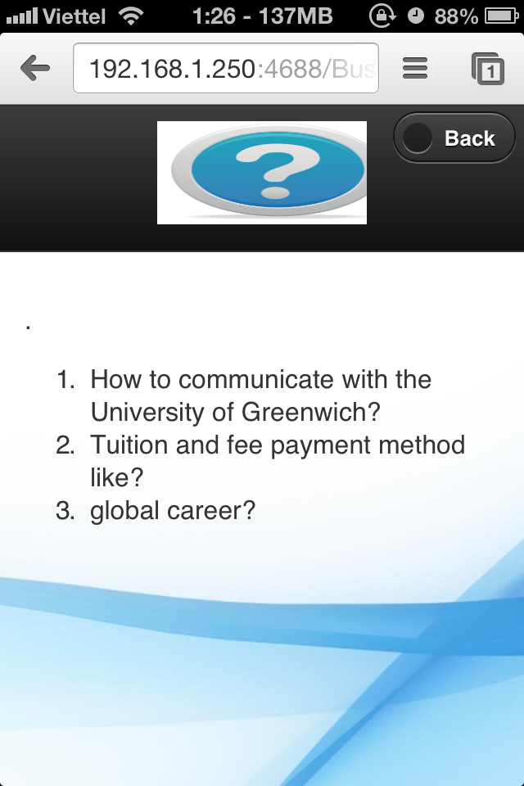

**3.4. Rule for Parent:** Parent must read rule to mornitor their son or daughter.

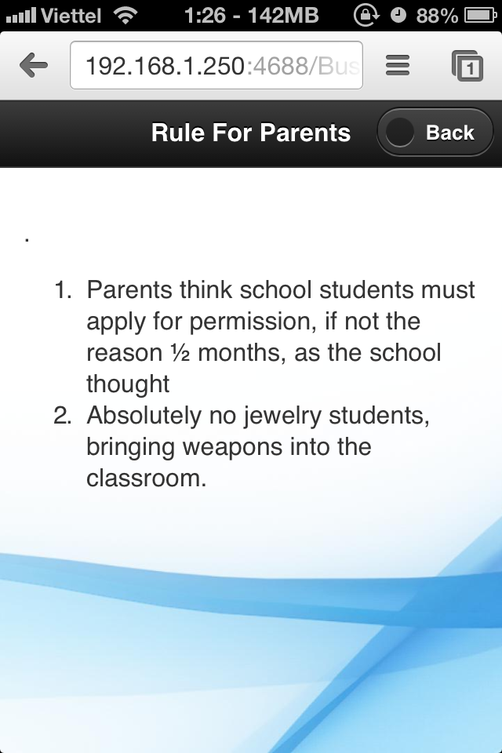

**4. About Greenwich**

**4.1. Contact Us**

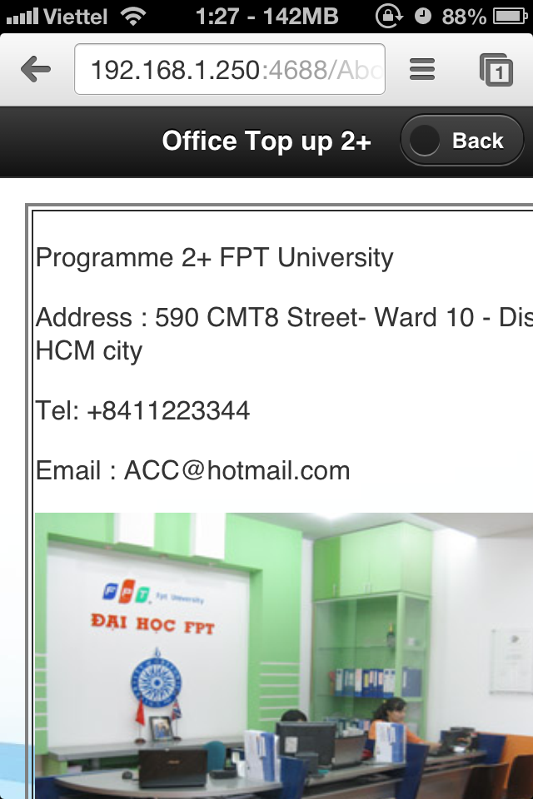

* 1. **Online Support**

